**PaNOSC**

**Photon and Neutron Open Science Cloud**

**H2020-INFRAEOSC-04-2018**

**Grant Agreement Number: 823852**

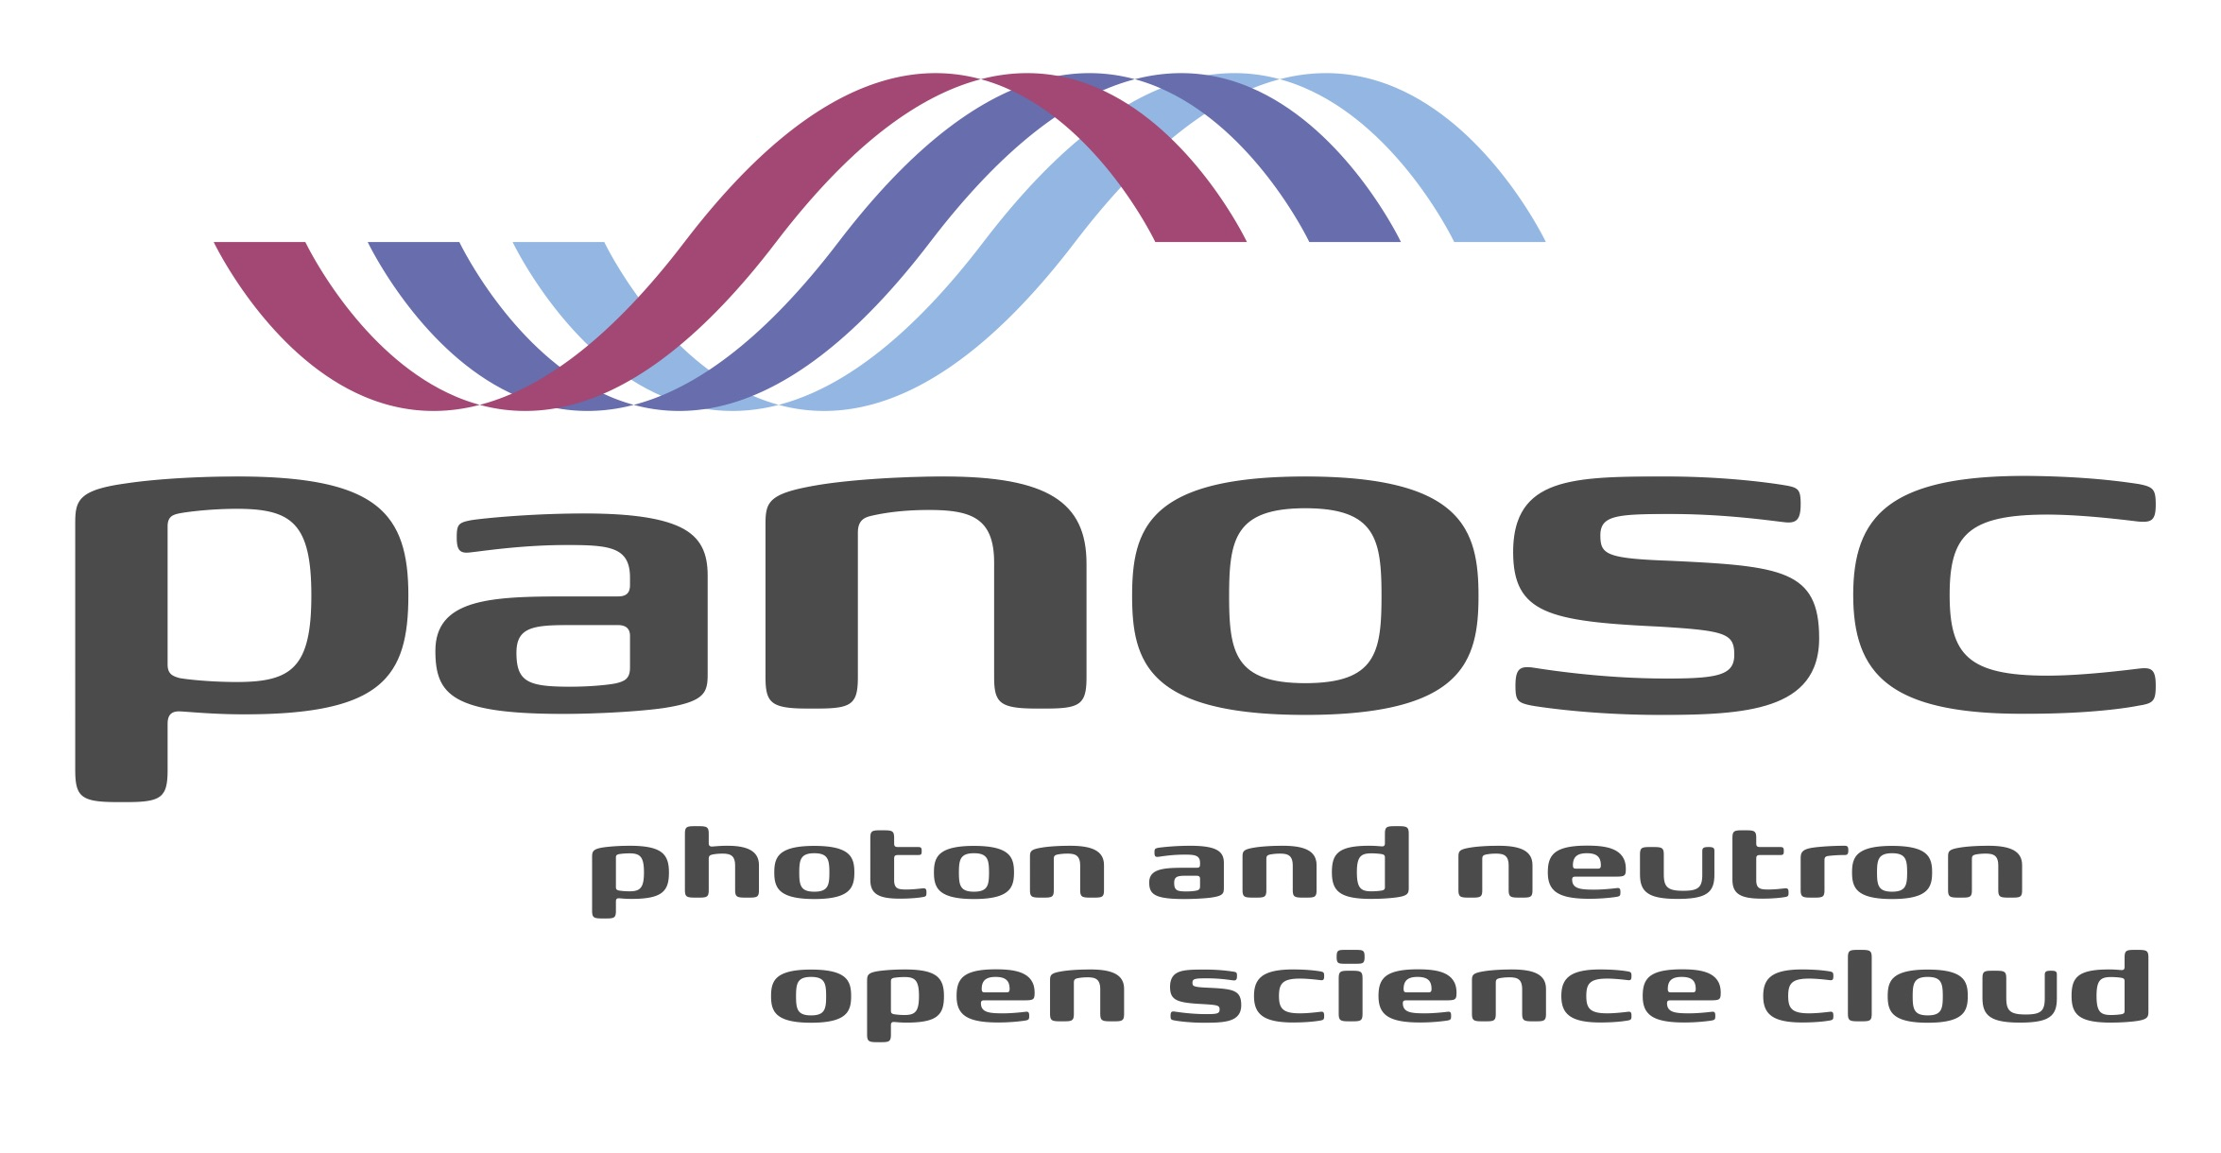

**Deliverable: 7.1 Photon and Neutron EOSC Stakeholder Feedback**

# Project Deliverable Information Sheet

|  |  |
| --- | --- |
| Project Reference No. | 823852 |
| Project acronym: | PaNOSC |
| Project full name: | Photon and Neutron Open Science Cloud |
| H2020 Call: | INFRAEOSC-04-2018 |
| Project Coordinator | Andy Götz (andy.gotz@esrf.fr) |
| Coordinating Organization: | ESRF |
| Project Website: | www.panosc.eu |
| Deliverable No: |  |
| Deliverable Type: |  |
| Dissemination Level |  |
| Contractual Delivery Date: |  |
| Actual Delivery Date: |  |
| EC project Officer: |  |

## Document Control Sheet

|  |  |
| --- | --- |
| **Document** | Title: Photon and Neutron EOSC Stakeholder Feedbacks |
| Version:1 |
| Available at: |
| Files: |
| **Authorship** | Written by: R.Pugliese |
| Contributors: J. Bodera Sempere, O. De Giacomo, Rudolf Dimper, F.Gliksohn, A. Götz, T. Holm Rod, J.F Perrin, D. Roccella |
| Reviewed by: G. Kourousias, Project coordinator |
| Approved: |

## List of participants

|  |  |  |
| --- | --- | --- |
| **Participant No.** | **Participant organisation name** | **Country** |
| 1 | European Synchrotron Radiation Facility (ESRF) | France |
| 2 | Institut Laue-Langevin (ILL) | France |
| 3 | European XFEL (XFEL.EU) | Germany |
| 4 | The European Spallation Source (ESS) | Sweden |
| 5 | Extreme Light Infrastructure Delivery Consortium (ELI-DC) | Belgium |
| 6 | Central European Research Infrastructure Consortium (CERIC-ERIC) | Italy |
| 7 | EGI Foundation (EGI.eu) | The Netherlands |

# 

**Table of Content**

Project Deliverable Information Sheet 2

Introduction 4

Approach and Methodology 4

Stakeholder Categories 6

Stakeholder List 9

The stakeholder database 14

Stakeholder Feedback 14

Feedback Collection Tools 15

References 16

# Introduction

This report describes the stakeholders for the Photon and Neutron Open Science Cloud community. The list of stakeholders will be used for creating links and collecting input and feedback for the execution of the PaNOSC project and for the relevance and sustainability of services within the EOSC. The stakeholders will be solicited for surveys and direct interaction whenever possible.

This report furthermore describes the methodology used to build the stakeholder database, presents the main categories of stakeholders and a preliminary list of them and a questionnaire to collect feedback from partners and observers. The final part includes a description of the survey tool to be used to collect the feedback from the stakeholders and a summary of the specific feedback that we have planned to ask to the stakeholders.

# Approach and Methodology

In January 2017 a European Project started with the goal to support the development of the first phase of the European Open Science Cloud (EOSC[1]).

The EOSC is supposed to provide a comprehensive and evolving set of services supporting an “open science”-friendly knowledge production lifecycle. The EOSC services shall allow stimulating the research process by the deposition and preservation of data, which can be discovered, accessed, used and reused.

The EU funded PaNOSC project started at the end of 2018 and is helping to align the efforts of the existing and new Photon and Neutron analytical facilities to link up to the EOSC.

To reach the right audience, the stakeholder list of EOSCpilot[2] has been analyzed. From this analysis process a list of stakeholder categories has been defined and then a list of stakeholders for the different types. A questionnaire has been then setup and circulated among the different partners and observers to improve both of them.

## Questionnaire (For Project Partners and Observers)

After an internal discussion the project team has defined the following survey that has been submitted to the project partners and observers. Observers are interested parties not directly involved as partners. Here is the online form that was used to collect feedback and update the stakeholder database.

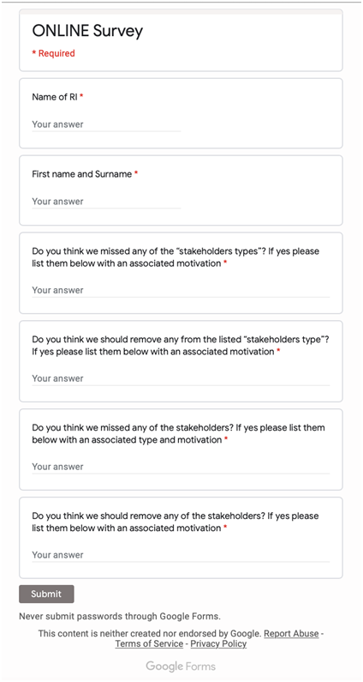

In the following chapters the initial stakeholder categories and the stakeholder database, resulting from the questionnaire analysis are presented.

# Stakeholder Categories

## Users, Research Communities and Institutions

Researchers, Research Communities and Research Institutions are the main beneficiaries of the developments undertaken in PaNOSC. They can be seen as the end-users of the services and their uptake will be crucial for the sustainability of what PaNOSC is developing. Universities have a special role, partly by having the most end-users, but also by being responsible for conveying an open science culture to a new generation of end users This is a broad class of stakeholders and will be most likely be best to interact with them through the User-Offices and User organisations in the Research Infrastructures and Universities as well as national user associations.

## Managers of Research Infrastructures

All data initiatives in facilities need to be dimensioned, planned and supported by the management of the facility. For this reason, together with the users, managers of research infrastructures are the most important stakeholders from the point of view of the sustainability of PaNOSC. They will be the ones to convey the importance of FAIR data to funders, assigning resources to his aim, ensuring the viability of a long term plan.

## RIs shareholders and funding bodies

All RIs shareholders and funding bodies are potential stakeholders of PaNOSC as at the end they fund the Research Infrastructures operations and their engagement is key to the sustainability of the EOSC in the long term.

## Other clusters and multi facility partners (CERIC-ERIC & ELI)

All research entities working with open data, cloud technologies and FAIR data principles are valuable allies in designing the framework for cloud services in the EU. Identifying key players in this sector is a significant challenge.

## Research funding organisations

Funding bodies both on national and EU level are major stakeholders in PaNOSC, since they support research in all its stages. Despite their different organizational schemes in different countries, PaNOSC needs to actively engage them in supporting the future direction of EU cloud infrastructures.

## Pan-European Research Infrastructures (ERIs)

The Pan-European Research Infrastructures, cluster projects of the EC and European Research Infrastructure Consortiums (ERICs) and other network of facilities complement the existing EU infrastructure landscape, by providing thematic (vertical) infrastructures in contrast to the horizontal e-infrastructure. RIs are the key starting point for engaging communities since they are already organized in an operational structure, have a large scientific user base and use or provide cloud services.

## National Research Infrastructures (NRIs)

The National Research Infrastructures complement the existing EU infrastructure landscape as even if funded by the single nations, provide services to researchers coming from Europe and extra-European countries. The data produced by these infrastructures should follow the same FAIR principles.

## Non-European Research Infrastructures (NERIs)

European photon and neutron sources share users and technology with non-European ones. Example of such infrastructures are SNS, JPARC, etc.

## Other European projects related to the EOSC

The projects funded by EC related to the EOSC are potential stakeholders as it may be worth to share ideas to implement services and tools thus avoiding re-inventing the wheel in order to speed up the EOSC construction. Other cluster projects of national facilities that are mirroring the ESFRI clusters like ExPANDS for instance, belong to this type.

## Policy makers

Policy makers affect cloud infrastructures in profound ways, even when they do not act as funders. For example, regulatory bodies on data privacy, on competition and of course on research can shape the future of the cloud ecosystem in the EU. PaNOSC has to identify the most closely related ones and investigate the best way how to engage them.

## Science clusters

The four other Science Clusters (ENVRI-FAIR, EOSC-LIFE, ESCAPE, SSHOC) and the national Photon and Neutron RIs are all working towards implementing the FAIR principles and linking to the EOSC. It will be important to align developments and future strategies or even work towards common developments. The Science Clusters will provide open data and users to the EOSC.

## ICT Industry, Industry associations and technology providers

Industry and commercial providers will be interested in providing cloud services but also to develop technologies and experiment systems to support the EOSC that may have then an economic value. Working on the EOSC may be an example of open innovation.

## Cloud providers

Public and private cloud service providers are by definition critical stakeholders in PaNOSC. Engaging major companies, e.g., Amazon, Google, Microsoft and others, that provide services to a wide range of research activities is essential for bringing together the needs of the research communities and the offered services, and to address some Data privacy issues.

## Data/Research Initiatives

There are a variety of organizations and initiatives, e.g., GO FAIR[3], FORCE 11[4], OpenAIRE[5], which constitute already organized research communities with specific stakes in policy validation and FAIR principles.

## e-Infrastructures

e-Infrastructures foster the emergence of Open Science, i.e. new working methods based on the shared use of ICT tools and resources across different disciplines and technology domains as well as sharing of results and an open way of working together. Furthermore, e-Infrastructures enable and support the circulation of knowledge in Europe and therefore constitute an essential building block for the European Research Area (ERA). A close dialogue with the European e-infrastructures will ensure that our users will find services which are adapted to the needs.

## Publishers

Every scientific article published in a journal is related to a set of raw data, metadata and results. The publishers could be PaNOSC stakeholders because it’s also in their interest that the dataset related to a specific article is Findable, Accessible, Interoperable, Reusable (FAIR principle).

# 

# Stakeholder List

| **Category** | **Name** | **Description** |
| --- | --- | --- |
| **Users, Research Communities and Institutions** | Project Partners | Every Project Partner of PaNOSC (ESRF, ILL, EU-XFEL, ESS, ELI-DC, CERIC-ERIC and EGI) is by definition a stakeholder of the project. In particular, to develop an efficient sustainability plan, the outcomes of every work package needs to be taken into account. |
| PaN Community | The Photon and Neutron Community was the first working group implementing a data policy (EU funded PaNData project), standard formats (NEXUS), user authentication (Umbrella) and catalog (ICAT). This community can contribute in terms of best practices and is a major stakeholder. The PaN scientific user community needs to be involved in the project to provide timely feedback on the project deliverables. In addition to PaNOSC, the national Photon and Neutron laboratories are working together in the ExPaNDS project which pursues similar, if not identical, goals than PaNOSC. Close interaction with ExPaNDS is necessary as well as interaction with other projects like CALIPSOplus that has a research activity quite aligned to PaNOSC goals. Another strong link with the PaN community will be through the LEAPS and LENS consortia and their respective user organizations ESUO and ENSA, which aim to bring their research infrastructures together for technical and scientific developments requiring a concerted effort. In the same sense an important stakeholder to be considered is the HERCULES school and other summer schools because they are a channel for spreading the outcome of PaNOSC (http://hercules-school.eu). |
| Users communities | The user community and their associations are one of the key types of stakeholders, in particular the European Neutron Scattering Association (ENSA: http://www.neutrons-ensa.eu) and the The European synchrotron and FEL user organisation (ESUO - http://esuo.org) |
| Managers of Research Infra-structures | All data initiatives in facilities need to be dimensioned, planned and supported by the management of the facility. For this reason, together with the users, managers of research infrastructures are the most important stakeholders from the point of view of the sustainability of PaNOSC. They will be the ones to convey the importance of FAIR data to funders, assigning resources to his aim, ensuring the viability of a long term plan. |

|  |  |  |
| --- | --- | --- |
| **Category** | **Name** | **Description** |
| **Research Communities and Institutions** | RDA[6] | The Research Data Alliance (RDA) is a research community organisation for open sharing of data across technologies, disciplines, and countries to address the grand challenges of society. The RDA is a major recipient of support in the form of grants from its constituent members’ governments. The RDA’s main vehicle for outputs are 18-month long working groups that generate recommendations aimed at the RDA community. In addition, interest groups with no fixed lifetime can produce informal or supported outputs which carry some degree of RDA endorsement.  It remains to be seen how the work in PaNOSC can be promoted in/by RDA and whether RDA recommendations can be applied within PaNOSC. |
| Managers of Research Infrastructures | All data initiatives in facilities need to be dimensioned, planned and supported by the management of the facility. For this reason, together with the users, managers of research infrastructures are the most important stakeholders from the point of view of the sustainability of PaNOSC. They will be the ones to convey the importance of FAIR data to funders, assigning resources to his aim, ensuring the viability of a long term plan. |
| **RIs shareholders and funding bodies** | PRACE[7][8]  Partnership | The mission of PRACE (Partnership for Advanced Computing in Europe) is to enable high-impact scientific discovery and engineering research and development across all disciplines to enhance European competitiveness for the benefit of society. PRACE seeks to realise this mission by offering world class computing and data management resources and services through a peer review process. PRACE could become a stakeholder in the PaNOSC endeavour if the PRACE business model is able to adapt to the needs of our scientific community by providing on demand services complementing their current peer review access to PRACE resources. |
| EURO-HPC | The EuroHPC Joint Undertaking is a 1 billion Euro joint initiative between the EU and European countries to develop a World Class Supercomputing Ecosystem in Europe. EuroHPC will become a key stakeholder of PaNOSC when they will achieve their goal, to permit the EU and participating countries to coordinate their efforts and share resources with the objective of deploying in Europe a world-class supercomputing infrastructure and a competitive innovation ecosystem in supercomputing technologies, applications and skills. |

|  |  |  |
| --- | --- | --- |
| **Category** | **Name** | **Description** |
| **Research funding organisations** | Research ministries across the EU | These are typical research funding organisations for national and European level research infrastructures: STFC, CNRS, CEA, CNR, INFN, MIUR, etc. |
| **Policy makers** | European Commission | The European Commission is the executive of the European Union and promotes its general interest. Following a major effort by the European Commission, the Member States and the scientific community, the European Open Science Cloud (EOSC) was launched to provide a safe environment for researchers to store, analyse and re-use data for research, innovation and educational purposes. The European Open Science Cloud is intended to set off the ground by federating existing scientific data infrastructures that are now spread across disciplines and EU member states. This will make access to scientific data easier and more efficient. The EOSC is projected to become a reality by 2020 and will be Europe’s virtual environment for all researchers to store, manage, analyze and re-use data for research, innovation and educational purposes. |
| EOSC Governance entities | The EOSC is governed by three constituent bodies, as defined by the “European Commission Staff Working Document Implementation Roadmap” for the EOSC. They are:  - *The Executive Board*, a body tasked to ensure implementation and accountability,  - *The EOSC Board*, gathering representatives from the Member States and the Commission to ensure effective supervision of the implementation, and  - *The Stakeholders Forum*, a group of representatives from a wider range of actors, tasked to provide input and recommendations. These three bodies are intended to be supported by the EOSCsecretariat, another EU funded project under the EOSC umbrella.  PaNOSC and the other ESFRI cluster projects will have to interact with the EOSC governance as they go along implementing FAIR data management. |
| **Data/**  **Research Initiatives** | Data/Research Initiatives | GO FAIR[9] FORCE 11[10] OpenAIRE  FAIRsFAIR |
| **Category** | **Name** | **Description** |
| **Other European projects related to the EOSC** | EOSC-hub | EOSC-hub brings together multiple service providers to create the Hub. The EOSC-hub is intended to be a single contact point for European researchers and innovators to discover, access, use and reuse a broad spectrum of resources for advanced data-driven research. For researchers, this will mean a broader access to services supporting their scientific discovery and collaboration across disciplinary and geographical boundaries.  The EOSC, with the two projects EOSC pilot (supporting the first phase) and EOSC-hub (create the integration and service management structure of the EOSC), will be strictly related with the goal of PaNOSC. |
| ESFRI cluster projects | The H2020 projects ENVRI, EOSC-LIFE, ESCAPE, and SSHOC have similar goals and it is necessary to keep a close relationship with their project managements to align as much as possible goals and deliverables. |
| Other related EU projects | EUDAT |
| **e-Infrastructures** | EGI Foundation | EGI is a federated e-Infrastructure set up to provide advanced computing services for research and innovation using grid computing techniques. This e-Infrastructure creates and delivers open solutions for science and research infrastructures by federating digital capabilities, resources and expertise between communities and across national boundaries. Researchers from all disciplines have easy, integrated and open access to the advanced scientific computing capabilities, resources and expertise needed to collaborate and to carry out data/compute intensive science and innovation. In this sense we can consider EGI as a stakeholder but also as a shareholder and a project partner. |
| GÉANT | Through its integrated catalogue of connectivity, collaboration and identity services, GÉANT provides users with highly reliable, unconstrained access to computing, analysis, storage, applications and other resources, to ensure that Europe remains at the forefront of research. According to their statements, over 1000 terabytes of data is transferred via the GÉANT IP backbone every day. Although most of the PaNOSC related services will be provided by EGI, GÉANT is an important stakeholder of PaNOSC. |

|  |  |  |
| --- | --- | --- |
| **Category** | **Name** | **Description** |
| **Cloud providers** | ICT Industry, Industry associations and technology providers | These will be in direct contact with EGI and PRACE even if we cannot exclude a direct connection with the PaNOSC project partners: Google, Amazon, Microsoft, IBM, etc. An example of technology provider is Jupyter project (http://www.jupyther.org). |
| **Publishers** | Publishers | Every scientific article published in a journal is related to a set of raw data, metadata and results. The publishers could be PaNOSC stakeholders because it’s also in their interest that the dataset related to a specific article is Findable, Accessible, Interoperable, Reusable (FAIR principle). |

# 

# The stakeholder database

The stakeholder database was filled in taking into account the feedback provided by partners and observers. The database a living document and is available as a shared spreadsheet on the cloud so that it can be kept constantly up-to-date and is available to all the project partners.

# Stakeholder Feedback

The feedback from stakeholders will allow us to address the tasks and finalize the other deliverables of the sustainability work package, in particular the deliverable “D7.2: Photon and Neutron EOSC metrics and costs model” which will develop and analyse metrics for the evaluation of costs and added value of the services provided to the community.

After the development of the first draft metrics and cost model, we will consider the feedback from stakeholders. The collected feedback will be used to refine the metric and the cost model in order to produce a final version of the metrics and cost model in November 2021.

Feedback can be collected in different ways. e.g. through face-to-face interactions during user meetings, user offices meetings, ERF, etc. The uptake of some of the services developed in PaNOSC can be collected with objective parameters such as the number of downloads, use, etc. This task is usually performed in the related Work packages. In the case of EOSC policy makers (EOSC Secretariat, Governing Board, Executive Board), the most effective way to engage may be the concertation days, organised by them as the preferred modality for interaction with the community. However, whenever necessary, targeted questionnaires will be developed and collected online or used as a base for the interviews.

The deliverable “D7.3: Photon and Neutron EOSC Business model reference document” will develop advanced business and funding models in connection with Industrial Liaison Offices of each facility, the user communities and all the relevant industrial and research community EOSC stakeholders. After a first draft of the business models we will consult stakeholders via a survey and we will refine it according to stakeholders’ consultation results. The final version of the business model reference document will be produced in May 2022.

In the same line in deliverable “D7.4: Photon and Neutron EOSC Sustainability plan” we will develop a formal long-term mission and vision for the sustainability of the PaNOSC infrastructure and software developed which will balance the viewpoints of the different stakeholder and the developed business models. After the preparation of a first draft we will launch a consultation with stakeholders and we will develop the final version based on the outcomes of the consultation. The final version of the sustainability plan will be produced in November 2022.

# Feedback Collection Tools

When direct interaction is not possible, surveys or survey forms are an efficient way to collect feedback from the PaNOSC stakeholders. Surveys also serve as an engaging factor. It seems reasonable to integrate these tools in the website of the PaNOSC project for increased community engagement. As the PaNOSC website is implemented in WordPress, we have decided to explore the possibilities to execute surveys and then track the survey execution via a WordPress survey plugin for further analysis.

We have thus searched for a suitable WordPress Survey plugin among the best Survey Plugins available: both Premium and Free. Here is the list of plugins that we have considered:

1.       Everest Forms (Premium)

2.       Opinion Stage (Free) - [the system we chose]

3.       WP-Polls (Free)

4.       eForm Builder (Premium)

5.       GetSiteControl (Free)

6.       Modal Survey (Premium)

7.       Modal Survey (Premium)

8.       Diker (Premium)

9.       Reputation Management (Premium)

Among the plugins one of the best seems Opinion Stage which is free and has options to create forms, surveys, quizzes as well as polls and slideshows. It also allows filtration options for polls according to categories, it permits to view all the details of the poll shares, it has many customization options including the possibility to add personalized forms with the project’s and facilities' logos.

Other options are to execute surveys via cloud services like google forms  (<https://www.google.com/forms/about/>) or SurveyMonkey (<https://www.surveymonkey.com>).  After the analysis we decided to use google forms that can be easily integrated with the website as the added value of using a specific wordpress plugin is not enough.

# References

[1] <https://eoscpilot.eu/about/eoscpilot-brief>

[2] <https://eoscpilot.eu/sites/default/files/eoscpilot_d2.7_submitted.pdf>

[3] <https://www.go-fair.org/>

[4] <https://www.force11.org/>

[5] <https://www.openaire.eu/>

[6] <https://rd-alliance.org/>

[7] <http://www.prace-ri.eu/prace-in-a-few-words/>

[8] <http://www.prace-ri.eu/members/>

[9] <https://www.go-fair.org/>

[10] <https://www.force11.org/>

[11] <https://ec.europa.eu/research/openscience/pdf/eosc_declaration.pdf>